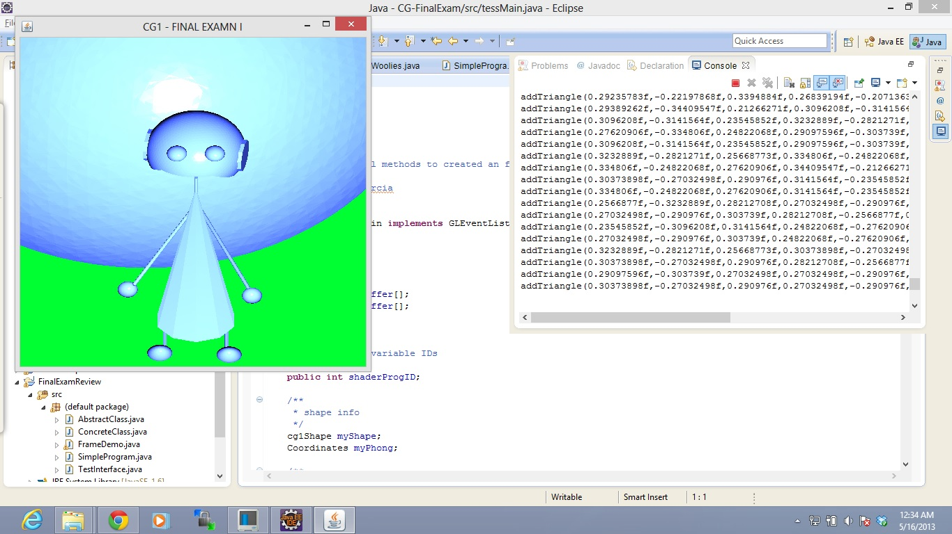
Java - CG-FinalExam/src/tessMain.java - Eclipse
-
O
X
Eil
CG1 - FINAL EXAMNI
-
O
X
: Java EE # Java
Quick Access Console X
Woolies.java
DSimple Progra.
Problems @ Javadoc
Declaration
1
1 methods to created an f
rcia
addTriangle (0.292357838,-0.221978685,0.3394884f, 0.268391948,-0.2071369 addTriangle (0.29389262f,-0.344095475,0.212662717,0.30962088,-0.3141564 addTriangle (0.30962085,-0.31415645,0.23545852f,0.32328898,-0.2821271f, addTriangle (0.276209061,-0.3348065, 0.248220681,0.290975965,-0.3037398, addTriangle (0.3096208,-0.3141564, 0.23545852f,0.29097596,-0.303739f addTriangle (0.32328898,-0.2821 .25668773f, 0.3348065,-0.248220 addTriangle (0.3348065,-0.24822068f ,0.27620906f, 0.344095471,-0.21266271 addTriangle (0.303738988,-0.27032498f, 0.290976f,0.31415645,-0.23545852f
riangle (0.334806f,-0.248220689, 0.27620906f,0.3141564,-0.23545852f addTriangle (0.25668775,-0.32328895,0.28212708f,0.270324981,-0.290976f, addTriangle (0.270324988,-0.290976f,0.3037398, 0.282127088,-0.25668778, addTriangle (0.235458528,-0.30962085, 0.31415645,0.248220681,-0.2762090€ addTriangle (0.270324988,-0.290 976f,0.3037398, 0.248220681,-0.27620906f, addTriangle (0.32328898,-0.2821271f, 0.256687738,0.303738988,-0.27032498 addTriangle (0.303738988,-0.270324985,0.290976f,0.28212708,-0.25668771 addTriangle (0.29097596f,-0.3037395,0.27032498f,0.27032498,-0.290976f, addTriangle (0.303738988,-0.270324985,0.2909765,0.270324988,-0.290976f,
in implements GLEventList
ffer[]; ffer();
variable IDs
public int shader ProgID;
* shape info
FinalExam Review
src . (default package)
► AbstractClass.java ► ConcreteClass.java ► D FrameDemo.java > SimpleProgram.java > Testinterface.java
*/
cg1Shape myShape; Coordinates myPhong;
-
IDC Cartons Tibran.
CC 1 61
Writable
Smart Insert
1:1
:

